**Introduction to the Poetry**

Funded by GATESOL, I had the privilege of presenting at the 2016 Peru TESOL conference in Arequipa. In this poem, I write about my inspiration of becoming fluent in Spanish by drawing on my interactions with and observations of locals and backpackers, non-native speakers of Spanish, in Cusco, Machu Picchu, Lima, and Ollataytambo beyond Arequipa during my extended 10-day stay in Peru. The image in Figure 1 below shows a free two-hour walking tour in Peru I joined through which I interacted with backpackers from around the world:

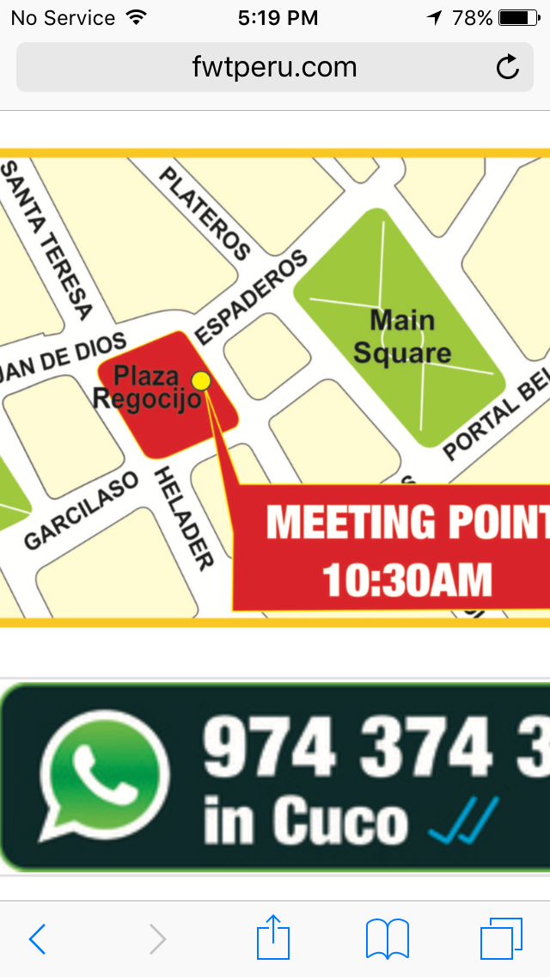

*Figure 1*. Memories from Peru. This is a screenshot of information about a free walking tour in Cusco. I found free walking tours in Peru very informative. It is also fun walking around the city with backpackers.

I describe how exhilarating it was to try out my limited Spanish and to watch crosslinguistic influences at work. In this poem, I write in all four languages of which I have varying proficiencies: Korean, English, Farsi, and Spanish in hopes to encourage teachers to allow multilingual students to draw on all linguistic repertoires when learning in school. Figures 2, 3, and 4 below illustrate how three languages, Korean, Farsi, and English, are integrated in our daily lives in my household:

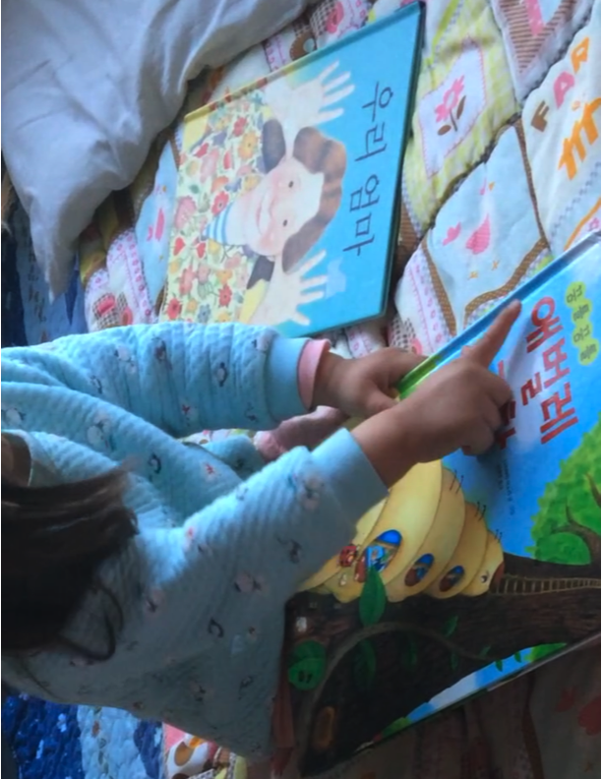

*Figure 2*. Korean books. My two-year-old daughter, who is growing up as a trilingual, is pretend reading a title of a children’s book in Korean.  
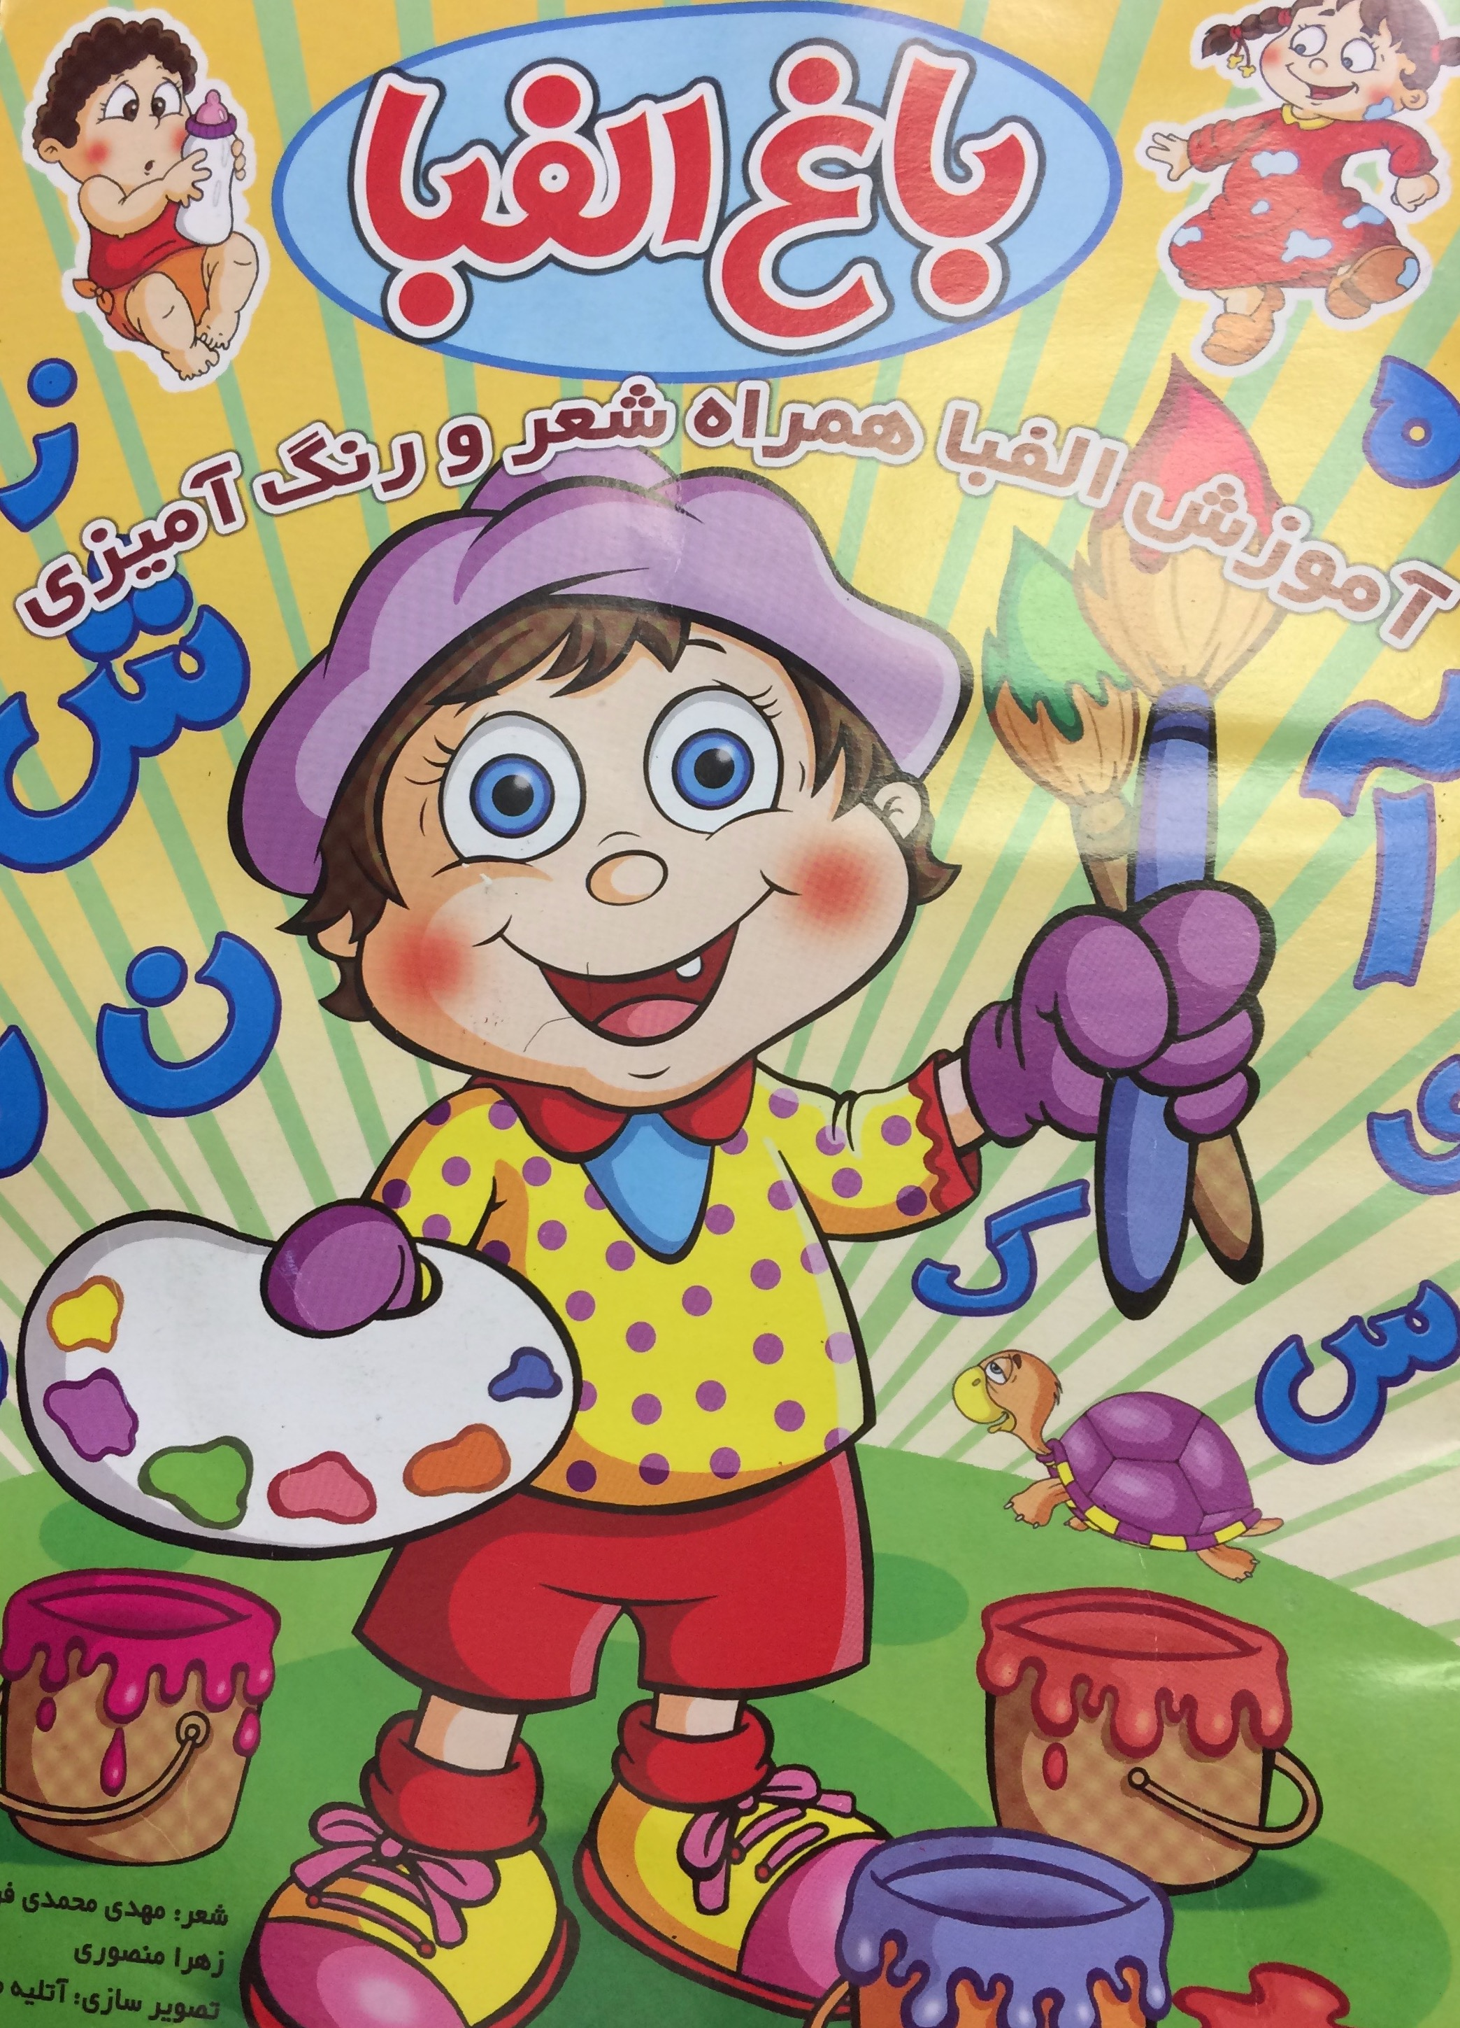

*Figure 3.* Farsi children’s book. I came across a children’s book in Farsi in a Farsi language class that my five-year-old son recently started attending on Sundays.

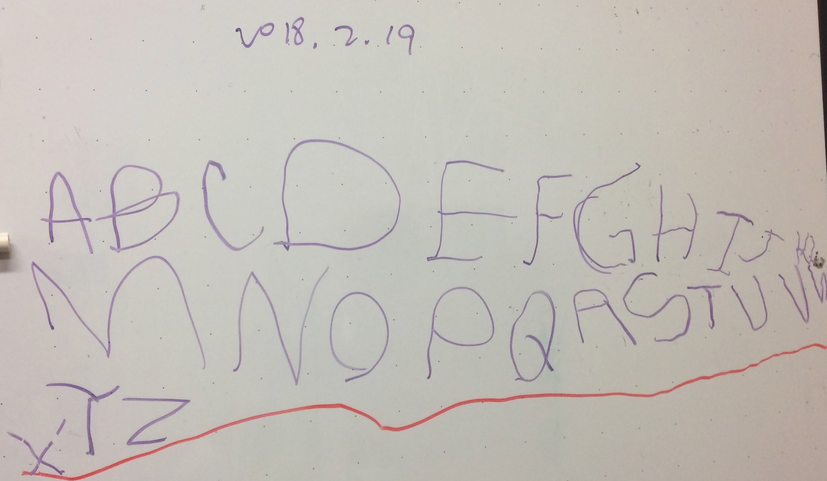

*Figure 4*. English language. My son, who is developing trilingual abilities, wrote English alphabet on white board when he came to my office.

This practice is called translanguaging, which is defined as “the deployment of a speaker’s full linguistic repertoire without regard for watchful adherence to the socially and politically defined boundaries of named (and usually national and the state) language”(Otheguy, García, & Reid, 2015, p. 283).

**Multilingual self: Inspired by a recent trip to Peru**

Forming a different identity

Speaking a foreign tongue in a new place

Being othered

It is exhilarating!

Yo soy coreana pero vivo y trabajo en Atlanta Georgia USA1

Me llamo Jayoung2

Excitedly, having a short conversation with locals in Cusco, Machu Picchu, Lima, Ollataytambo, and Arequipa

Unexpectedly, my third language, Farsi, was crawling out when using Spanish

What is happening here? 이란어가 여기저기서 왜 불쑥불쑥 튀어나오지?!3

In place of por que, چون که 4popped out

بله pushed out sí5

I took a step back and amusedly watched crosslinguistic influences at work

BUT, My Spanish did not go much far…

Why did I wait all these years not learning Spanish?

Oh boy, I grew envious of

A young college student from the U.S. who could converse in Spanish fluently with a beautiful English accent

A Polish backpacker who naturally picked up enough Spanish by travelling

I can be like them, *non-native speakers* of Spanish

If they can do it, I can do it. 저 정도는 나도 조금만 시간 투자하면 할 수 있지, 그럼!6

Hopeful and inspired

I return to my two young kids and my full-time job in an English-speaking country

Like my teachers who wish to learn the languages of their students but who don’t have the time

I also struggle to carve out a time to keep the momentum and passion

But I cannot put it off again!

I have promised myself to go back with much-improved Spanish soon

And start to figure myself in Spanish too

Notes

1. In Spanish, “I am Korean but I live and work in Atlanta, GA, U.S.A.”

2. In Spanish, “My name is Jayoung.”

3. In Korean, “Why is my Farsi popping out here and there?”

4. In Spanish and Farsi, “because”

5. In Farsi and Spanish, “yes.”

6. In Korean, “I can speak Spanish that much if I invest more time in learning, for sure”

**Concluding Thoughts**

I have chosen to write about my experience in Peru particularly in the genre of poetry. When I had a strong urge to express my bursting desire of becoming a proficient Spanish speaker, I could not think of a more suitable medium than poetry. Poetry served well for me as I desired to get my thoughts on paper and start dialoguing with others quickly. This genre, unlike a long prose or an academic paper, permits fewer words to carry my inspirations and reflections in a more impactful manner. This genre can especially be powerful for multilingual writers as it conspicuously highlights the use of multiple languages in it. Multilingual writers who could be teacher educators, teachers, and K-12 students can employ translanguaging through which they purposefully and strategically choose words and sentences in one language over another to express more layered meaning. Please see Ofelia García and her colleagues’ work on translanguaging as well as translanguaging guides and resources on the Web, https://www.cuny-nysieb.org.

**References**

García, O., Johnson, S. I., & Seltzer, K. (2016). *The translanguaging classroom: Leveraging student bilingualism for learning*. Philadelphia, PA: Caslon Publishing.

García, O. & Kleyn, T. (Eds.). (2016). *Translanguaging with multilingual students: Learning from classroom moments.* New York, NY: Routledge.

García, O., & Wei, L. (2015). Translanguaging, bilingualism and bilingual education. In W. E. Wright, S. Boun, & O. Garcia (Eds). *The handbook of bilingual and multilingual education* (pp. 223-240). Hoboken, NJ: Wiley-Blackwell.

Otheguy, R., García, O., & Reid, W. (2015). Clarifying translanguaging and deconstructing named languages: A perspective from linguistics. *Applied Linguistics Review, 6*(3), 281-307. doi:10.1515/applirev-2015-0014